Travelling Salesman Problem (TSP)
Aim
To implement the Travelling Salesman Problem (TSP) using Python.
Objective
- To determine the shortest route that visits every city exactly once.
- To return to the starting city with minimum total cost.
Algorithm
- Define the distance matrix.
- Select the starting city.
- Generate all possible permutations of remaining cities.
- Calculate the total distance for each route.
- Select the route with the minimum distance.
- Display the shortest path and its cost.

FLOW CHART
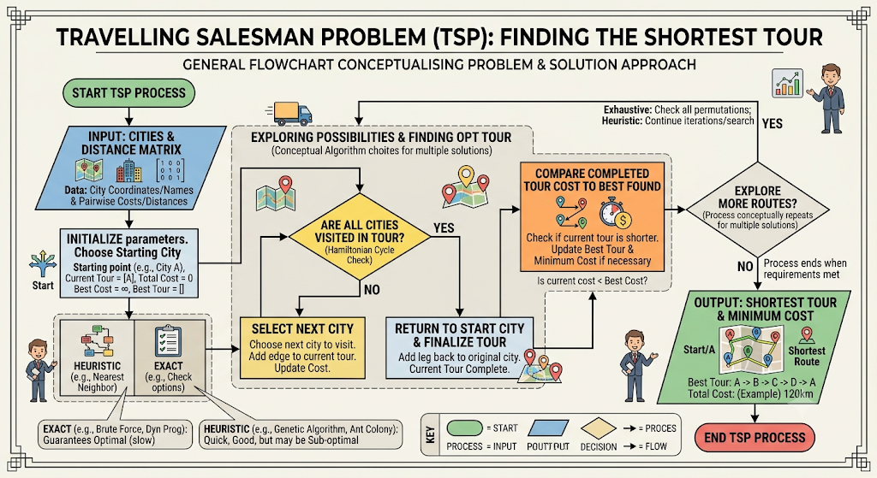

PYTHON CODE

graph = [
[0, 10, 15, 20],
[10, 0, 35, 25],
[15, 35, 0, 30],
[20, 25, 30, 0]
]

n = len(graph)
cities = list(range(1, n))

min_path = float('inf')

for perm in permutations(cities):
cost = 0
k = 0

for city in perm:
cost += graph[k][city]
k = city

cost += graph[k][0]
min_path = min(min_path, cost)

print("Minimum Cost:", min_path)

RESULT
